Ideation Phase
Empathize & Discover

Date | 31 January 2026
Team ID | LTVIP2026TMIDS62122
Project Name | Startup Success Prediction System Using Machine Learning
Maximum Marks | 4 Marks

Empathy Map Canvas:
An empathy map was created to better understand the needs, behaviors, and challenges of the target users, primarily startup founders and early-stage entrepreneurs. Many founders feel uncertain and anxious about whether their startup idea will succeed, especially when significant time and financial resources are involved. They often struggle to interpret complex market trends, funding patterns, and industry competition without access to structured analytical tools. While they are motivated and excited about innovation, they also fear failure and financial loss. By viewing the problem from the user’s perspective, it becomes clear that founders require a simple, reliable, and data-driven solution that can help them evaluate their startup’s success probability. This understanding guided the development of the Startup Success Prediction System to address real user concerns and support confident, informed decision-making.
Example:
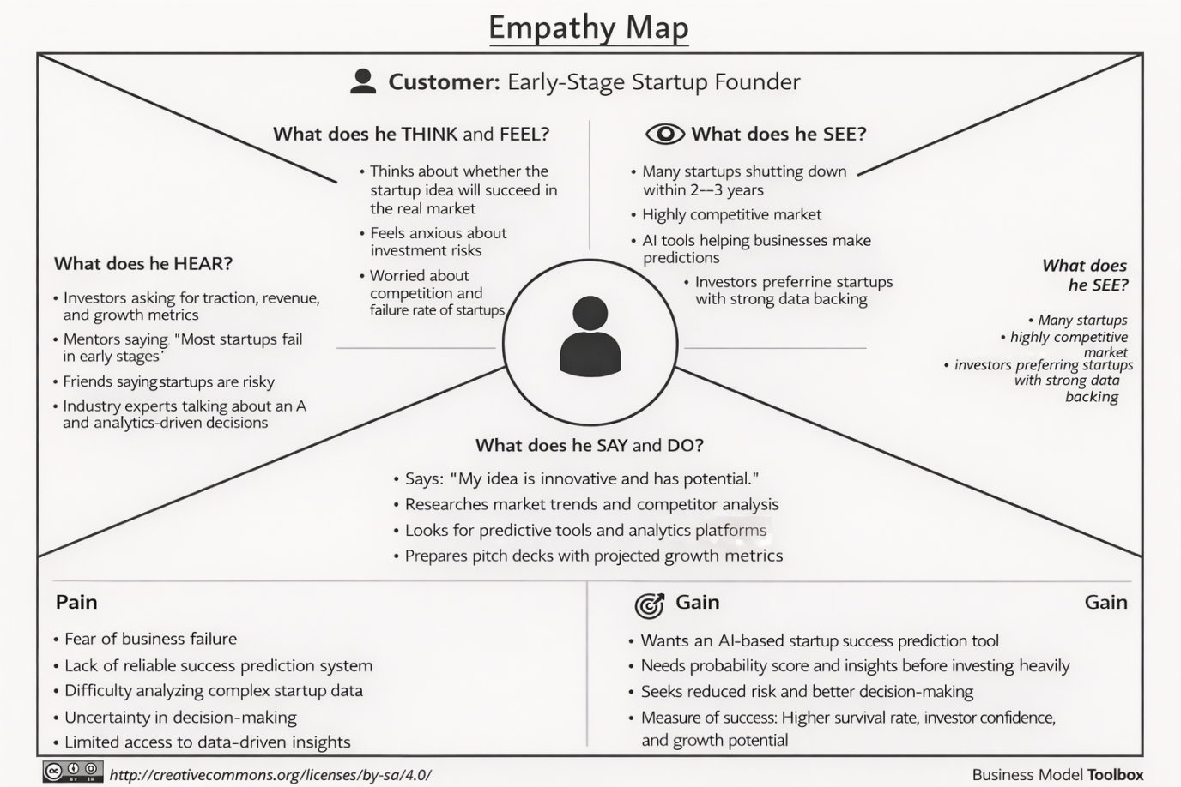

Example: Food Ordering & Delivery Application
